Viewing MM910 EasyLink Status
Scenarios
View the MM910 EasyLink status on the HMM WebUI. In this topic, Internet Explorer 11 is used as an example.
Prerequisites
Conditions
The IP address of the local computer and the IP address of the server MM910 management network port are on the same network segment.
Data
You have obtained the following data:
- IP address and subnet mask for the MM910 management network port
- User name and password for logging in to MM910
Procedure
            - Open Internet Explorer, enter the IP address of the MM910 management network port in the address box, and press Enter.
The address format is http://IP address of the MM910 management network port.
The security alert dialog box is displayed.
            - Click Continue to this website (not recommended).
The login page is displayed, as shown in Figure 1-1.
              - HMM login page
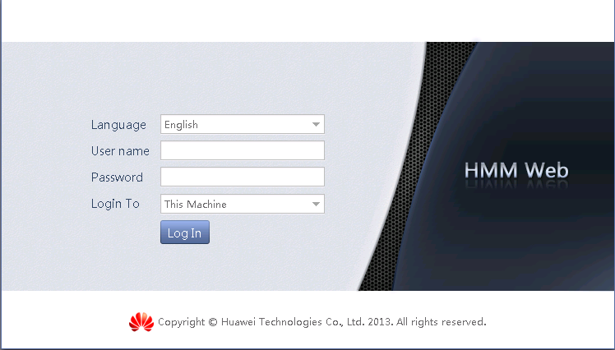

            - On the login page, set the parameters as follows:
- Select a language.
- Enter the user name. The default user name is root.
- Enter the password. The default password is Huawei12#$ or root.
- Select This Machine from the Log on to drop-down list.
- Click Log In.
The HMM management page is displayed, as shown in Figure 1-2.
              - HMM WebUI
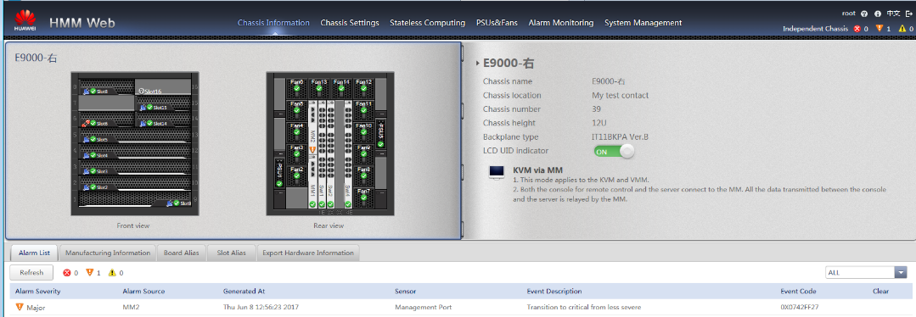

            - Choose Stateless Computing > easyLink Configuration > Switch Centralized Management.
The Switch Centralized Management page is displayed. You can view the Switch Centralized Management Configuration which indicates the status of easyLink, as shown in Figure 1-3.
Note: If there is no Stateless Computing or Stateless Computing without easyLink Configuration, the current MM910 version does not support easyLink.
              - Switch Centralized Management
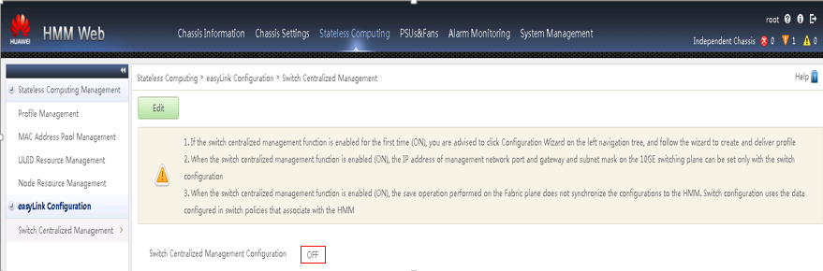

---End

